WEEK 2

AIM :
To implement and use lambda expressions in Java by creating methods that return lambda expressions to check whether a given number is odd or even, prime or composite, and palindrome or not, using a functional interface.
ALGORITHM :
• Create a functional interface PerformOperation with a single abstract method
boolean check(int a).
• Create a class MyMath that contains:
- A method checker() to apply a given lambda operation on a number.
- A method isOdd() that returns a lambda expression to check if a number is odd.
- A method isPrime() that returns a lambda expression to check if a number is prime.
- A method isPalindrome() that returns a lambda expression to check if a number is palindrome.
• In the main() method:
- Read the number of test cases.
- For each test case, read the operation type and the number.
- Based on the operation type:
  - Call isOdd(), isPrime(), or isPalindrome() to obtain the corresponding lambda expression.
  - Pass the lambda expression and number to the checker() method.
- Print the appropriate result.
PROGRAM :
public static PerformOperation isOdd() {
return a -> a % 2 != 0;
}

public static PerformOperation isPrime() {
return a -> {
if (a <= 1) return false;
for (int i = 2; i <= Math.sqrt(a); i++) {
if (a % i == 0) return false;
}
return true;
};
}

public static PerformOperation isPalindrome() {
return a -> {
int temp = a, rev = 0;
while (temp > 0) {
rev = rev * 10 + temp % 10;
temp /= 10;
}
return rev == a;
};
}
}
Output :
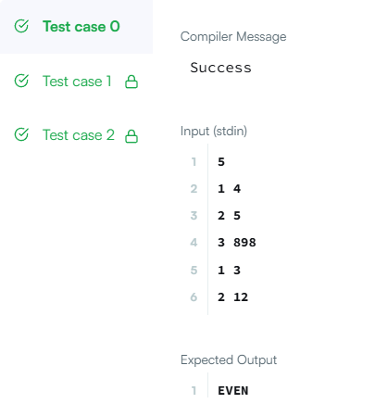
Result :
It correctly used lambda expressions and a functional interface to determine whether the given numbers are odd or even, prime or composite, and palindrome or not, and displayed the appropriate output for each test case.

MIN – MAX PROBLEM :
PROGRAM :
import java.io.*;
import java.util.*;
class Result {
static void miniMaxSum(List<Integer> arr) {
long sum = 0;
int min = Integer.MAX_VALUE, max = Integer.MIN_VALUE;
for (int n : arr) {
sum += n;
min = Math.min(min, n);
max = Math.max(max, n);
}

System.out.println((sum - max) + " " + (sum - min));
}
}

public class Solution {
public static void main(String[] args) throws Exception {
BufferedReader br = new BufferedReader(new InputStreamReader(System.in));
String[] input = br.readLine().split(" ");

List<Integer> arr = new ArrayList<>();
for (int i = 0; i < 5; i++) {
arr.add(Integer.parseInt(input[i]));
}

Result.miniMaxSum(arr);
}
}

Output :
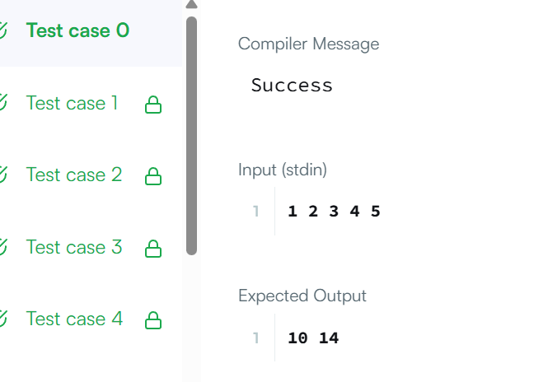

IS-PALINDROME PROBLEM :
PROGRM :
public class practice{
public static boolean ispalindrome(String name){
int n = name.length();
for(int i=0;i<n/2;i++){
if(name.charAt(i) != name.charAt(n-i-1)){
return false;
}
}
return true;
}
public static void main(String[] args) {
String name = "noop";
System.out.println(ispalindrome(name));
}
}
OUTPUT :
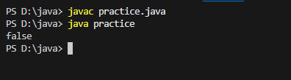

ALL DIGIT COUNT :
PROGRAM :
class UserMainCode
{
public int allDigitsCount(int input1)
{
int count = 0;
int num = input1;
while (num != 0)
{
count++;
num = num / 10;
}
return count;
}
}

OUTPUT :
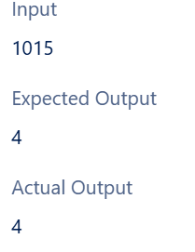

JAVA DATE AND TIME
PROGRAM
public static String findDay(int month, int day, int year) {

Calendar cal = Calendar.getInstance();
cal.set(year, month - 1, day);

int dayOfWeek = cal.get(Calendar.DAY_OF_WEEK);

String[] days = {
"SUNDAY",
"MONDAY",
"TUESDAY",
"WEDNESDAY",
"THURSDAY",
"FRIDAY",
"SATURDAY"
};

return days[dayOfWeek - 1];
}
}

OUTPUT :
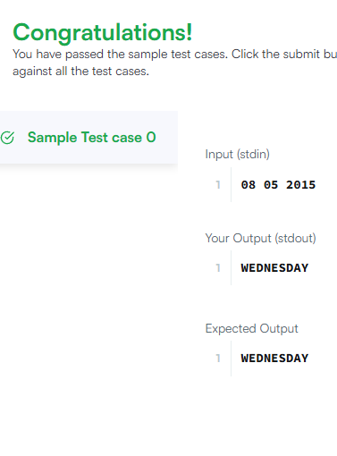

HILL PATTERN :
PROGRAM :
import java.io.*;
import java.util.*;
class UserMainCode
{
public int totalHillWeight(int input1, int input2, int input3)
{
int total = 0;

for (int i = 1; i <= input1; i++) {
int weightPerStar = input2 + (i - 1) * input3;
total += i * weightPerStar;
}
return total;
}
}

OUTPUT :
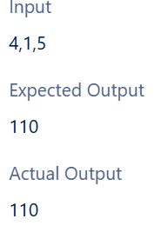

SUM OF SUMS OF DIGIT
PROGRAM :
import java.io.*;
import java.util.*;
class UserMainCode {
public int sumOfSumsOfDigits(int input1) {
String num = String.valueOf(input1);
int total = 0;
for (int i = 0; i < num.length(); i++) {
int currentSum = 0;
for (int j = i; j < num.length(); j++) {
currentSum += num.charAt(j) - '0';
}
total += currentSum;
}
return total;
}
}OUTPUT :
